**RECEIVING LABEL**

The Receiving Label is generated at the time we received the raw material on GSS.

Label is 1.5 X 3.5”

Receiving Label Contain:

* **Part Number (P/N:)**
* **Revision Part (REV:)**
* **Date of Receiving (DATE RCD:)**
* **Description Part (DESC:)**
* **Receiving Number (REC#:)**
* **Supplier (SUPP:)**
* **Purchase Order (PO#:)**
* **Manufacturing Name (MFG:)**
* **Quantity Pcs Received (QTY REC:)**
* **Manufacturing Model (MOD:)**
* **Bin Number (BIN:)**
* **Received Name (REC BY:)**

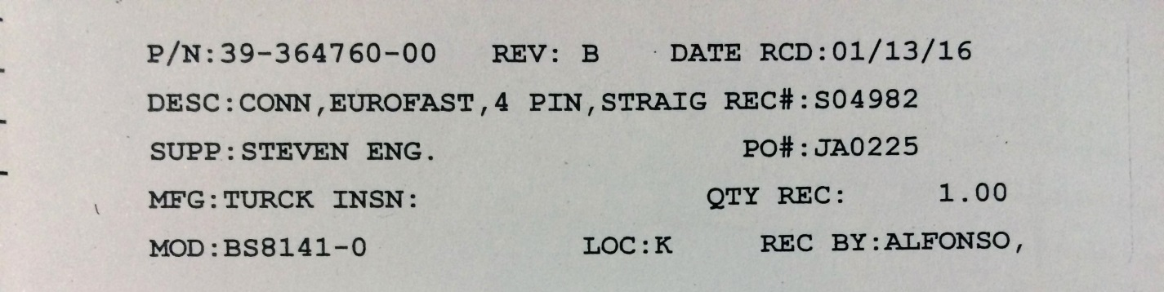

Actual Label (1”X4”)Avery 4013

**Data field**

**Part Number:**

Inventory purchase part number

**Revision Part:**

Revision of the part number

**Date of Receiving:**

Date of the received on GSS was made

**Description Part:**

Description part number

**Receiving Number:**

GSS Received Order Number.

**Supplier:**

The supplier or vendor name.

**Purchase Order:**

GSS purchase order number.

**Manufacturing Name:**

The manufacturer name of the part number should came from GSS reference part inventory.

**Quantity Pieces Received:**

Quantity pieces received.

**Manufacturing Model:**

The manufacturer model part number should came from GSS reference part inventory.

**Bin Number:**

Should be come from GSS part number inventory

**UOM:**

Inventory part number Unit of Measure

**Received Name:**

The first name of the user who made the Receiver Order on GSS.

**Requires Inspection:**

Flag YES or NOT.

INVENTORY> FILE> INVENTORY> OPEN > PARTS OPTION> REQUIRES INSPECTION FLAG

**Requires Testing:**

Flag YES or NOT.

INVENTORY> FILE> INVENTORY> OPEN > PARTS OPTION> REQUIRES TESTING FLAG

Label size is 1.5 X 3.5”

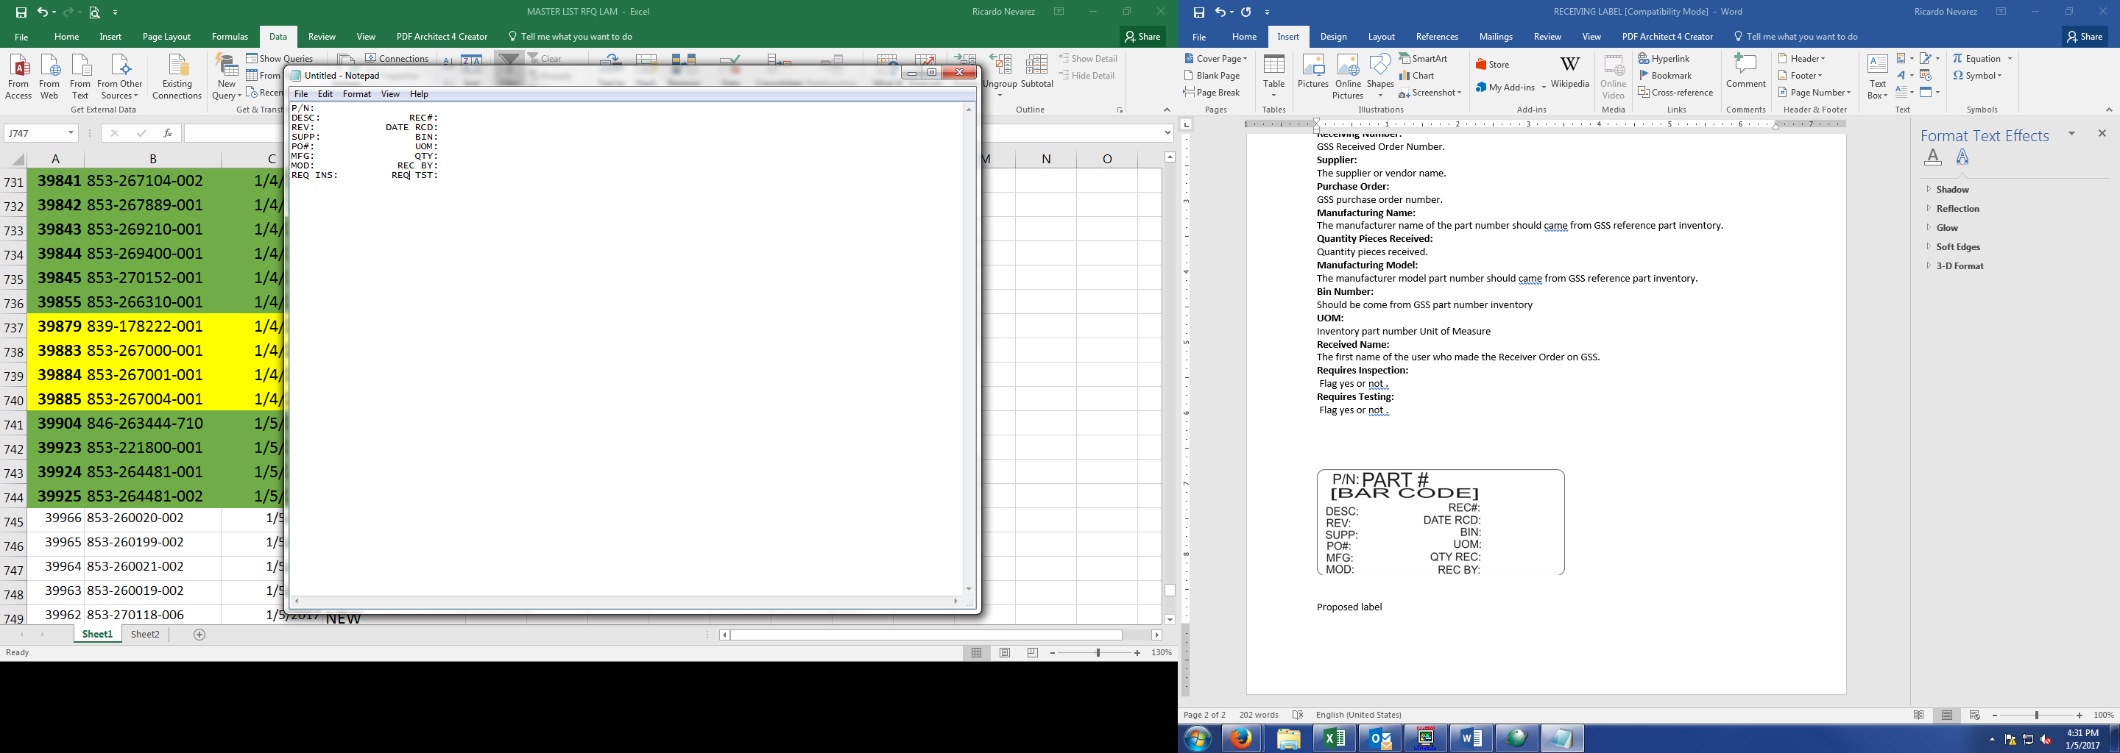

Proposed label